Sample Database
Since 2005, Popular Scale Model Supplier (PSMS) is a company that supplies scale plastic models around the world. PSMS carries a huge range of made-up plastic model kits from popular manufacturer such as Revell, Academy, Hasegawa, Tamiya, Hobbyboss, Trumpeter and other scale model vendors. Their product lines includes Classic Cars, Motorcycles, Planes, Ships, Trains, Trucks and Buses and Vintage Cars. The range of scale models kits contain about 3500 models from 60 producers, on a scale from 1:35 to 1:700.

Currently, PSMS uses a database to maintain all its transactional data. The logical design is as shown below.
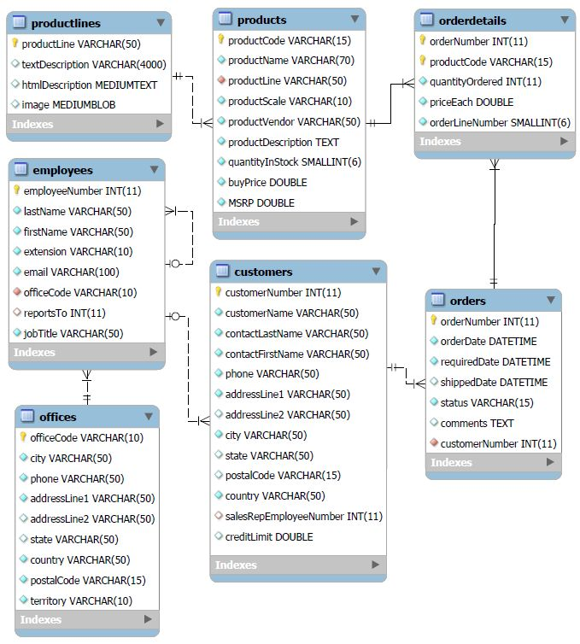
Logical design of PSMS database

The physical design if the database is as follow:

CREATE TABLE productlines(
productLine varchar(50) NOT NULL,
textDescription varchar(4000) DEFAULT NULL,
htmlDescription varchar(1000),
image blob,
PRIMARY KEY (productLine)
);

CREATE TABLE products(
productCode varchar(15) NOT NULL,
productName varchar(70) NOT NULL,
productLine varchar(50) NOT NULL,
productScale varchar(10) NOT NULL,
productVendor varchar(50) NOT NULL,
productDescription varchar(4000) NOT NULL,
quantityInStock number(4) NOT NULL,
buyPrice number(7,2) NOT NULL,
MSRP number(7,2) NOT NULL,
PRIMARY KEY (productCode)
);

CREATE TABLE offices(
officeCode varchar(10) NOT NULL,
city varchar(50) NOT NULL,
phone varchar(50) NOT NULL,
addressLine1 varchar(50) NOT NULL,
addressLine2 varchar(50) DEFAULT NULL,
state varchar(50) DEFAULT NULL,
country varchar(50) NOT NULL,
postalCode varchar(15) NOT NULL,
territory varchar(10) NOT NULL,
PRIMARY KEY (officeCode)
);

CREATE TABLE employees(
employeeNumber number(11) NOT NULL,
lastName varchar(50) NOT NULL,
firstName varchar(50) NOT NULL,
extension varchar(10),
email varchar(100),
officeCode varchar(10),
reportsTo number(11) DEFAULT NULL,
jobTitle varchar(50),
PRIMARY KEY (employeeNumber)
);

CREATE TABLE customers(
customerNumber number(11) NOT NULL,
customerName varchar(50) NOT NULL,
contactLastName varchar(50) NOT NULL,
contactFirstName varchar(50) NOT NULL,
phone varchar(50) NOT NULL,
addressLine1 varchar(50) NOT NULL,
addressLine2 varchar(50) DEFAULT NULL,
city varchar(50) NOT NULL,
state varchar(50) DEFAULT NULL,
postalCode varchar(15) DEFAULT NULL,
country varchar(50) NOT NULL,
salesRepEmployeeNumber number(11) DEFAULT NULL,
creditLimit number(9,2) DEFAULT NULL,
PRIMARY KEY (customerNumber)
);

CREATE TABLE orders(
orderNumber number(11) NOT NULL,
orderDate date NOT NULL,
requiredDate date NOT NULL,
shippedDate date DEFAULT NULL,
status varchar(15) NOT NULL,
comments varchar(500),
customerNumber number(11) NOT NULL,
PRIMARY KEY (orderNumber)
);

CREATE TABLE orderdetails(
orderNumber number(11) NOT NULL,
productCode varchar(15) NOT NULL,
quantityOrdered number(4) NOT NULL,
priceEach number(7,2) NOT NULL,
orderLineNumber number(3) NOT NULL,
PRIMARY KEY (orderNumber,productCode)
);

